Favela Rising Anticipation Guide

Mark each continuum is the way that best represents how you feel about each statement. Be prepared to discuss your answers!

Strongly Agree Not Sure Disagree Strongly
Agree Disagree
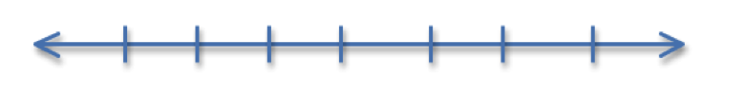

- A single person cannot change a problem in a community

- Poverty causes violence

- Only the government can solve the problems of a community

- Music can change a person’s life

Background for Favela Rising Questions As you read, answer the following questions to analyze the AfroReggae movement and it's purpose.

Important Information to Note:
- Switzerland is known as one of the richest, most equality-based nations in the world
- India is known as one of the poorest nations in the world. Here, the gap between rich and poor is huge, with people from different classes unable to change their station in life.
- Genocide: the deliberate killing of a large group of people, especially those of a particular ethnic group or nation.
- Social mobility: the ability of people to move from one social group to another. Example: growing up in a poor environment, but working hard and ending up earning a high wage
- Socioeconomic: relating to or concerned with the interaction of social and economic factors. Example: race and class

Civil Society in Brazil: AfroReggae
- What does the Switzerland/India metaphor mean in relation to Brazil?

- What are favelas?

- Why do the youth in the favelas turn to drugs?

- What does “genocide of poor youth” mean? What statistic backs up this claim?

- The mission of GCAR is “to promote social inclusion and social justice…” Do you think music can accomplish this? What from your life has led you to believe this?

AfroReggae’s Beginnings
- Describe the relationship between the people of the favelas and the police:

From Guns to Drums
- What does AfroReggae focus on? Why is this important?

- How does AfroReggae attract the youth of the favelas?

